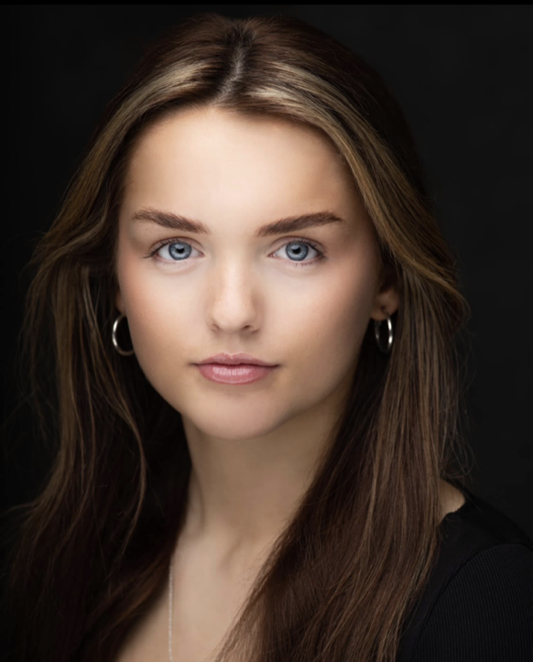
Madeline Hewett
Email : Maddy.hewett@hotmail.co.uk
Phone: 07856023594
Playing age: 14-30
Height: 5’4
Hair: Brown
Eye: Blue
Gender: Female
Build: Medium
Nationality: British

Training
BA (Hons) Musical Theatre- Wales Academy of Voice and Dramatic Arts – Graduating 2026 Level 3 Extended diploma – Liverpool Institute of Performing Arts – Graduated 2022

Credits Include

Production | Roles | Venue/Company | Director
California Dreaming | Duet Partner | Edinburgh Fringe/ Night Owl Shows | Daniel Clews
Advertisement | Actress | Zenith| Next Gen Media | Tash White
Music Video | Dancer | BREEZE | Albert Anderson
Advertisement | Swimwear Model | FIFTY1 Clothing Liverpool Store | FIFTY1
‘Sister Act’ Musical | Joey/ ensemble | Willy Russell Theatre | Eddie Chinn
‘LIPI4’ Girlband | Soprano Singer | Stage-Pro Academy | Toured UK | Joanne Edwards

Skills
Accents: Northern English | Liverpudlian | RP | Californian | southern American
Singing: Dramatic Soprano
Dance: Intermediate Jazz| Intermediate Tap | Intermediate Ballet | Intermediate Commercial Stage Combat: Combat: Basic Unarmed (Merit)
Other: cycling, contortion, Sailing, Kayaking, Pantomime, roller skating,

